[ Insert official UPAEP logo ]
UPAEP · Decanato de Ingenierías
EVIDENCE — US16-T1
Define automatic irrigation rules
SmartGreenAI: Cilantro Crop

1. Task information
Task ID | US16-T1
User Story | US-16 — Automatic irrigation according to predefined conditions
Sprint | Sprint 3 (2026-10-12 – 2026-10-30)
Week | Week 1
Responsible | Oscar Abraham Talavera Nava
Peer reviewer | Vicente Rocha Alfaro
Planned / actual hours | 2 h / 2 h
Completed on | October 16, 2026
Status | Done

2. Task description
Rule: in AUTOMATIC mode, if the average soil moisture of the area is below the minimum threshold for 2 consecutive readings, turn the pump ON until the target is reached or the maximum duration ends; then wait for the cooldown. Default values: target 65%, maximum 10 min, cooldown 30 min.

3. Completion conditions
✓ Condition 1: Rule document with parameters and default values.
How it was verified: Rule: in AUTOMATIC mode, if the average soil moisture of the area is below the minimum threshold for 2 consecutive readings, the pump turns ON until the target is reached or the maximum duration ends; then the cooldown applies. Parameters and defaults:
Parameters (irrigation_config)
Parameter | Default | Current value
target_moisture | 65 % | 65 %
max_duration_min | 10 min | 10 min
cooldown_min | 30 min | 30 min
consecutive_readings | 2 | 2
min_tank_level | 20 % | 20 %
enabled | true | true

✓ Condition 2: Flowchart of the rule.
How it was verified: Flowchart of the rule:
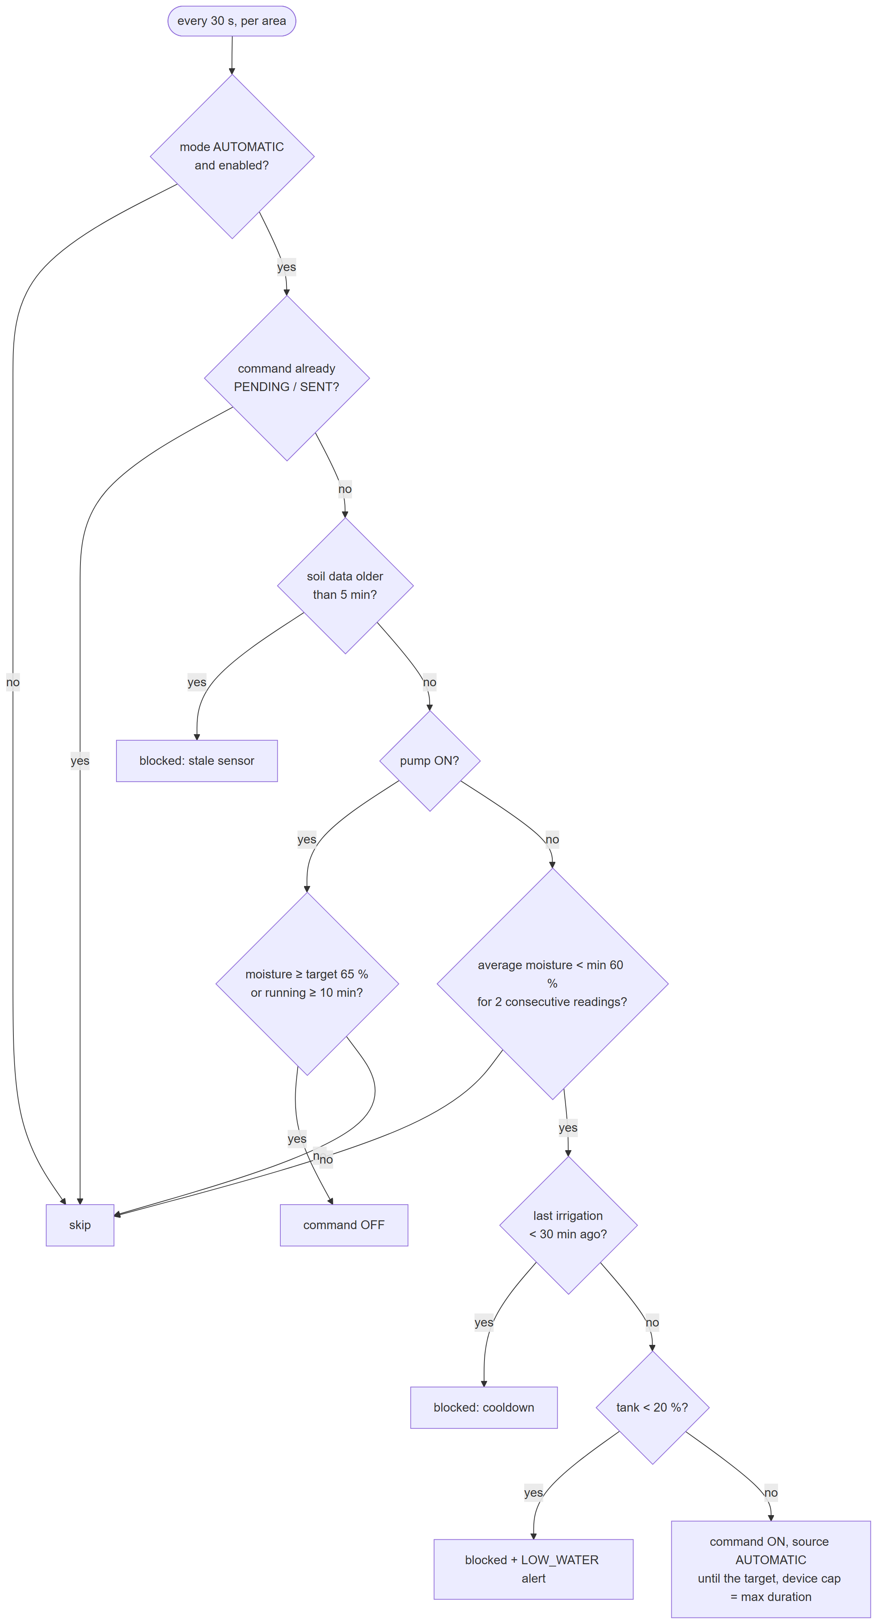
Figure US16-T1-1. Flowchart of the automatic irrigation rule with its safety conditions. (US16-T1_Define_Automatic_Irrigation_Rules_1.png)
✓ Condition 3: Approved by the Product Owner.
How it was verified: Approved by the Product Owner (approval record).
✓ Condition 4: Evidence: Rule document and flowchart approved by the PO.
How it was verified: Rule document and flowchart approved by the PO.

4. Attached files
- US16-T1_Define_Automatic_Irrigation_Rules_1.png

5. Traceability
Related requirements | FR-18, NFR-08
Implementation | schema.sql → irrigation_config; defaults in seed.sql (target 65 %, max 10 min, cooldown 30 min, 2 readings, tank 20 %)
Verification | —

6. Sign-off
Role | Name | Date | Signature
Responsible | Oscar Abraham Talavera Nava | October 16, 2026
Peer reviewer | Vicente Rocha Alfaro | October 16, 2026
Product Owner acceptance | Alexis Enrique Valle Parra | October 16, 2026
Approval record: Daily Meeting 2 of Sprint 3 (Monday, October 19, 2026), Scrum board: "Tasks moved to Done last week: US11-T1, US11-T2, US12-T1, US13-T1, US13-T2, US15-T1, US15-T2, US15-T3, US15-T4, US15-T5 (early), US16-T1, US16-T2, US17-T1, US19-T1, US19-T2, US19-T3."

